Indoor Pens for Pigs
By Julie Romero
Pigs need to have a proper amount of indoor space if you are keeping your pig indoors at all. As the pig grows so does the space need to.
Piglets can be set up with a proper safe space very easily. They need to be from day one. They should always have a safe place to be when they are unattended.
Pigs/Piglets should always be quarantined (enforced isolation) when coming into a home with other pigs for the sake and safety of the residing pigs/piglets. Mange, mites, and a whole host of other contagious things can be brought in and infect your herd very quickly and end up being a huge issue when quarantine procedures are not followed. By this I do not mean a baby gate separating them. If they can get that close, they can contaminate each other. This needs to be done until dewormed and a full vet check has been done.
Males and females who are intact, should always be separated. Males have been known to breed as early as 8 weeks old, sometimes even younger. Females can become pregnant as early as 3 months, even earlier sometimes. It is always better to error on the side of caution and assume if they are unaltered they can breed. Keep them apart. Breeders have often reported pigs breeding through multiple fences, so keep that in mind when looking at how far apart you have your males and females. If you think it is far enough, move them farther apart!
Crates and cages are used by many as a safe place to put a pig at night or while you run to the store for a few minutes during the day. Pigs get bored very easy, but as they get older they sleep a lot. Piglets need more room, they are busier. Puppy fences are not made for pigs. Pigs are strong, and sturdy and built like tanks.
Here are some examples of good indoor containments for piglets.
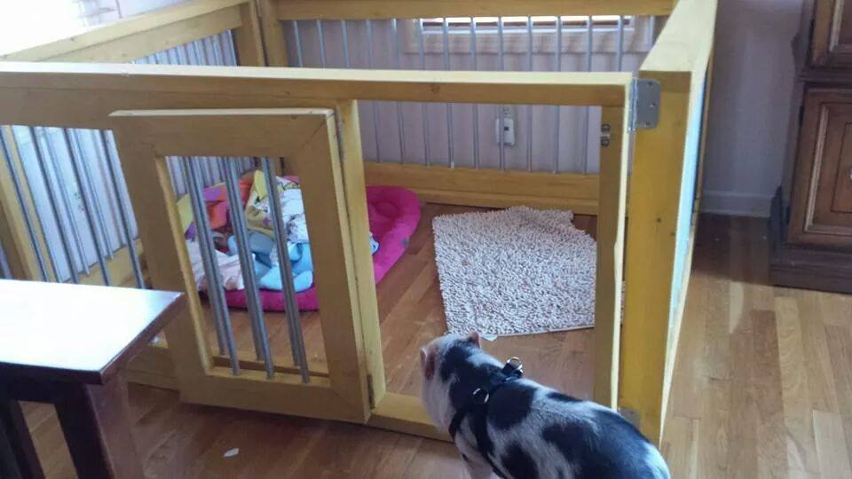
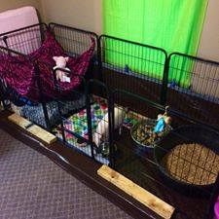

Always remember to keep your pig safe and secure at all times. You can also get stickers for your doors and the window to the room the pig is in from the fire department to alert them that there are animals in the residence in case of a fire.
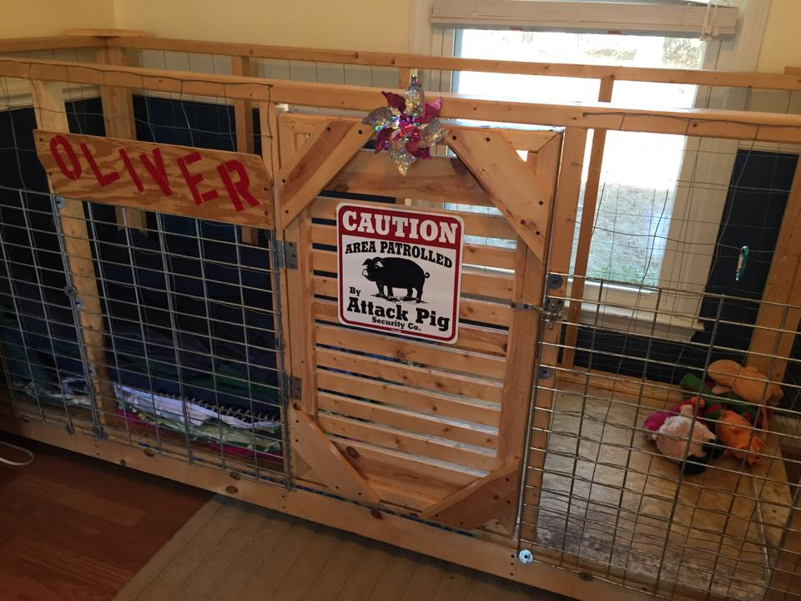
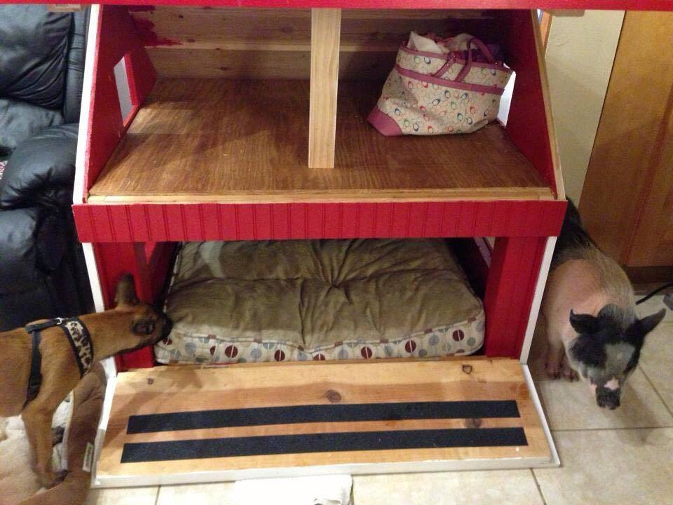
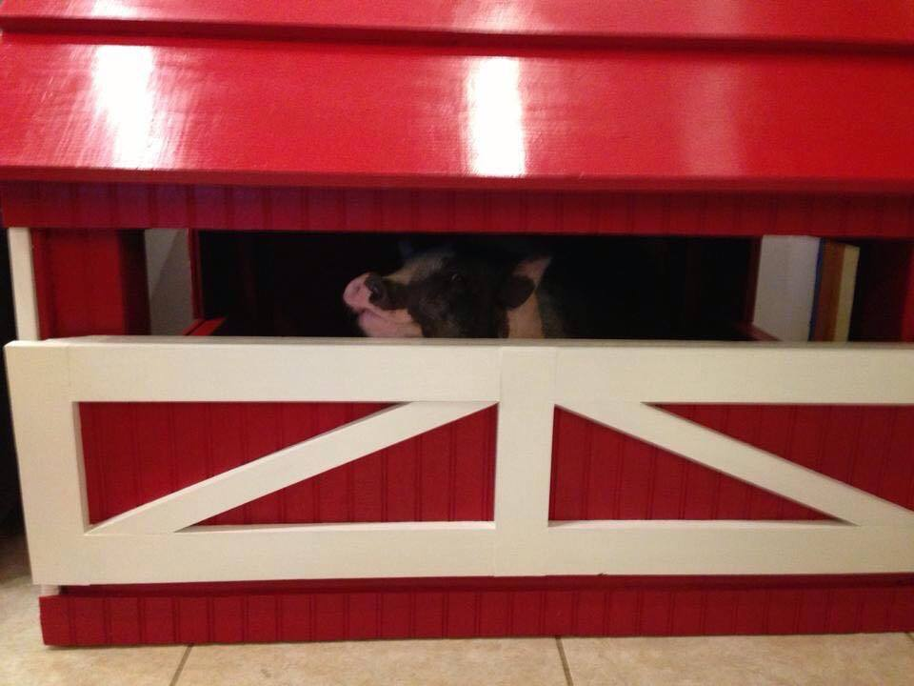
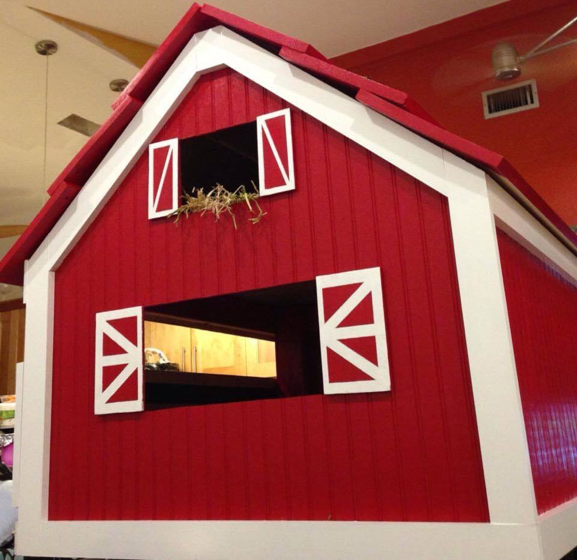
Here is some good indoor containment for adult pigs.
