Teeth
By Julie Romero
A pig is born with eight (8) what is called needle teeth, or cutters. Some breeders will have these trimmed before you get your piglet.
Mini pigs will get three (3) sets of teeth through their life. Each time a new set of teeth come in the old teeth will be pushed out, much like we see with human children. The last set of teeth should come in between the age of 18-22 months of age.
Tooth Eruption
 | Deciduous | Permanent
Incisors | Birth - 2 weeks | 8 - 18 months
Canines | Birth | 8 - 12 months
Premolars | 2 weeks - 8 month | 12 - 16 months
Molars |  | 4 - 22 months

Somewhere between the Deciduous (first set) and the Permanent (third set) there is a second set between there, which does not follow much of a set timeline.
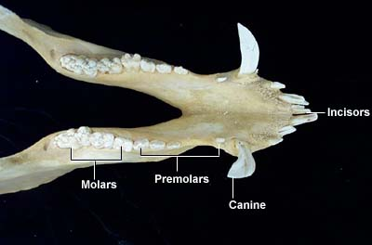
Often times while they are losing their teeth you will notice your lil sweetheart grinding their teeth. Some never do, but quite a few do. Some pigs will grind their teeth so much it is even in their sleep. It can become a very frustrating time for the owner as the grinding can be very loud and irritating. Some suggestions at this time are to give some harder veggies for your little angel to chew on. Carrots are perfect at this time, or celery. One of my pigs lost a tooth in a carrot! I was so thrilled because she immediately stopped grinding her teeth. We were then able to sleep all night as her bed is in our bedroom.
Pigs will also grow tusks, both male and female. If they are spayed or neutered the tusks grow much slower. Females rarely need any tusks trimmed. Males may need their tusks trimmed annually if that is your preference. Some chose to do that, for safety of the family and children. Others choose to never get them trimmed. I personally have never had my boys tusks trimmed. One of the boys tusks is about 3 inches long, the other about 1 inch. My female has none visible at all.
The first tooth I found was a molar. It was just lying on the floor and looked very odd. It looked like three teeth in one. I ran to the computer, and looked up pig teeth to see if that was what it was. Sure enough it was! Here is a photo.
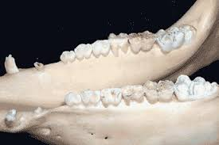
I still have that tooth! It is the very back on in the photo on the right. Often time’s people find them in their food dishes, or water dishes, or in their bedding. So be on the look out!

*Table and photos from arbl.cvmbs.colostate.edu

